**Assignment -1**

Python Programming

|  |  |
| --- | --- |
| Assignment Date | 19 September 2022 |
| Student Name | Varsha.R |
| Student Roll Number | 311019104097 |
| Maximum Marks | 2 Marks |

1.Create registration page in html with username, email and phone number and by using POST method display it in next html page.

<!DOCTYPE html>

<html>

<body>

<h1>Post Attribute</h1>

<form action="/action_page.php" method="post" target="_blank">

<label for="Username">Username:</label>

<input type="text" id="USERNAME" name="Username"><br><br>

<label for="email"> Email:</label>

<input type="text" id="Email" name="Email"><br><br>

<label for="Phone_number">Phone_number:</label>

<input type="Number" id="Phone_number" name="Phone_number"><br><br>

<input type="submit" value="Submit">

</form>

</body>

</html>

**Output:**

**Post Attribute**

Top of Form

Username:   
  
Email:   
  
Phone_number:   
  


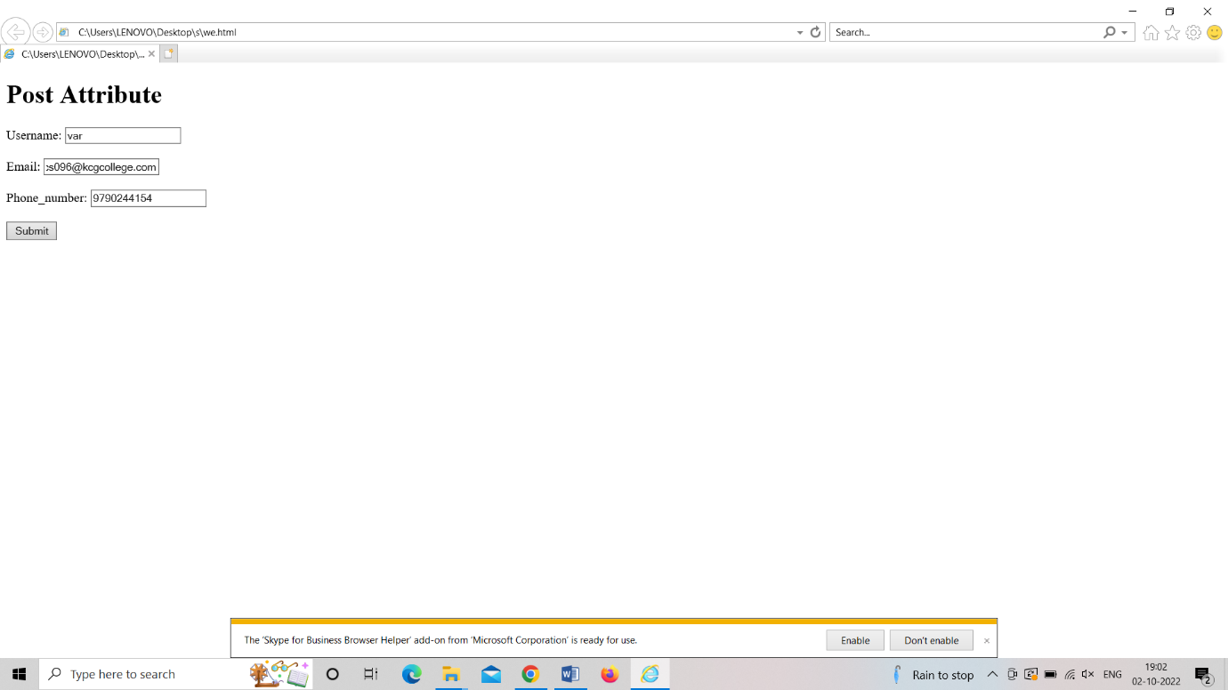

Bottom of Form